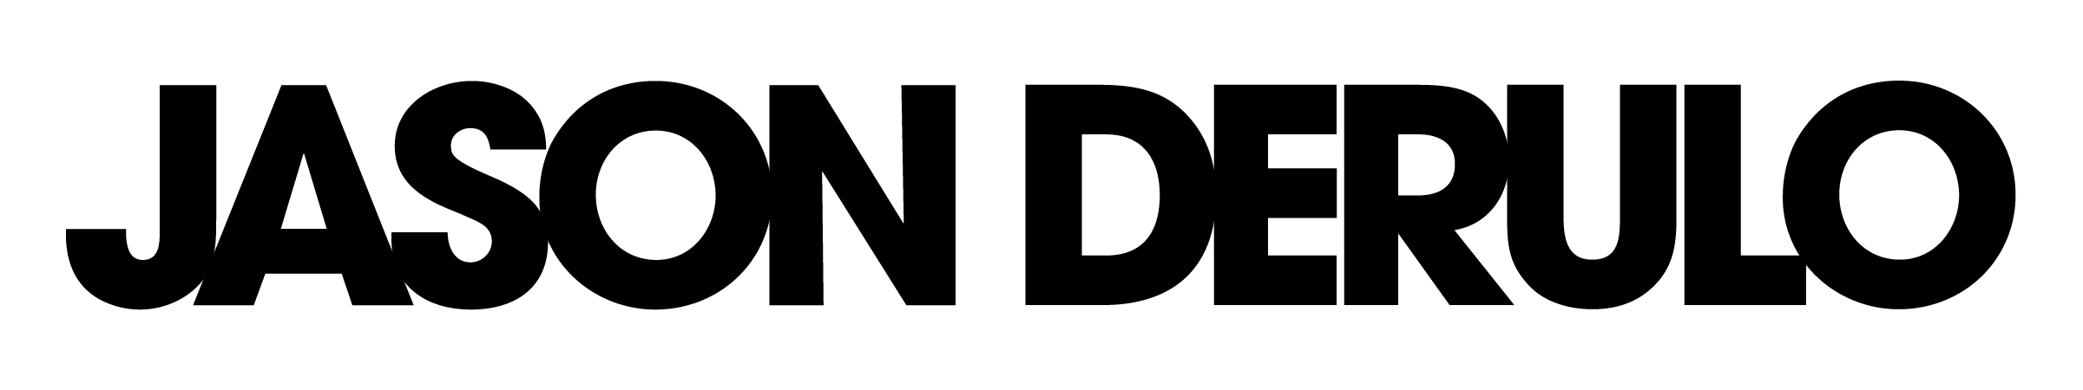

Over 45 Million Singles Sold Worldwide.
Over 1.2 Billion Views on YouTube.
Five Top 5 US Radio Singles in the Top 40 Format. (Seven In The Top 10)
A Cumulative US Radio Audience of Over 15 Billion.
Over 20 Million Social Media Fans and Followers.
Think You Know Jason Derulo?

In his short 5-year career, Jason Derulo has proven to be a contender with pop music’s biggest hitters, and his rise to fame isn’t slowing down yet. Jason’s latest single “Talk Dirty” (ft. 2 Chainz) is his most successful track to date having sold over 5 million singles throughout the world, and has garnered over 200 million views on YouTube and climbing. Led by early champions internationally, the song took off overseas quickly becoming a #1 hit in the UK, Germany, Australia, France, Belgium and New Zealand before taking over the US radio charts in January 2014.

Friends and contemporaries such as One Direction, Ariana Grande, Robin Thicke, Bow Wow, and Flo Rida have all added their stamp of approval on the track supporting Jason via the “Celebrities Talkin’ Dirty” viral video which premiered on Derulo’s YouTube channel sparking even more chatter on his most playful and provocative song yet.

Success hasn’t always come easy for the 24-year-old pop singer. After a string of career defining hit singles including “Whatcha Say,” "In My Head," "Ridin' Solo," "Don't Wanna Go Home" and "It Girl,” Derulo suffered a catastrophic neck injury, which forced him to rehabilitate himself both mentally and physically. He released his comeback record “The Other Side” from his newly announced Tattoos LP in May 2013, which became radio’s #1 most added record of the year and set Derulo on a new and re-energized path.
The success of the “The Other Side” prompted Jason to rethink the rollout of his new materials. Derulo would release an 11-song LP titled Tattoos abroad, which went on to become a top 5 record in the U.K. and Australia, and a 5-song EP stateside in September 2013.

Inspired by the success of “Talk Dirty,” Jason headed back to the studio to polish off his third U.S. studio effort, aptly titled Talk Dirty, recalibrating the collection of songs released on Tattoos. 2 Chainz, Snoop Dogg, Tyga, Jordin Sparks, Kid Ink, and Pitbull all lend their talents to Talk Dirty with production efforts by Timbaland, DJ Mustard, RedOne, The Cataracs, Jon Bellion, Wallpaper, Jim BEANZ, Ammo, Martin Johnson, Jonas Jeberg, BeatGeek, Sam Sumser, Jared Lee, Rush and Chloe Angelides.

The album represents a bridge between Derulo’s past and future, covering more mature subject matter with more complex beats and arrangements, but all back dropped behind the hit songwriting Derulo has become known for.

Derulo describes, "With The Lights On," as "a big performance record with a party vibe” while “Zipper” includes “some hip-hop-inspired punch lines and some interactive moments for the listener to participate." On the beautiful, stripped-down duet "Vertigo," Jason pairs his smooth tenor with the sweet, airy sounds from his Idol beauty Jordin Sparks. "It's a really important song that rounds out the album because although I am living in this very fun time, I'm also in love with her," says Derulo. "It's just us and the piano and keeps the emotional aspect of the album from getting lost.”

“Wiggle,” a mid-tempo track featuring Snoop Dogg, was Derulo’s next single following “Talk Dirty.” "It's probably the best song on the album, it's a sure-shot in your face," he says. "It's one of the most fun records you've ever heard in your life." The record was his 8th song to reach at least the Top 10 at Top 40/mainstream format and his 9th single to sell at least one million copies.

Derulo’s career started after penning hits for the likes of Lil Wayne, Pitbull, Diddy, Sean Kingston, Cassie, and Danity Kane at 16 years of age. Following his 2009 self-titled debut, the 24-year old Miami native has since received nods from the Teen Choice Awards, the MTV Europe Music Awards, the MOBO Awards, and five honour’s at the BMI Pop Awards including Songwriter of the Year in 2011.

Talk Dirty Track Listing

- Talk Dirty Feat. 2 Chainz (produced by Wallpaper)
- Wiggle Feat. Snoop Dogg (produced by Wallpaper)
- Trumpets (produced by Jon Bellion)
- Bubblegum Feat. Tyga (produced by Jim BEANZ; co-produced by Timbaland)
- Vertigo Feat. Jordin Sparks (produced by Jared Lee)
- Kama Sutra Feat. Kid Ink (produced by DJ Mustard)
- Zipper (Produced by Cirkut, Sam Sumser & Chloe Angelides)
- The Other Side (produced by Ammo and Martin Johnson)
- With The Lights On (produced by The Cataracs)
- Stupid Love (produced by RedOne, Rus, and BeatGeek)
- Marry Me (produced by Jonas Jeberg)
- Tattoo (Target Bonus Track)
- Fire feat.Pitbull (Target Bonus Track)

